Press Release
February, 2014
TERA K15 Mark II: for quick and easy THz material analysis
At Photonics West, Menlo Systems exhibited the latest generation of compact, fully fiber-coupled, turn‐key THz time‐domain spectrometer: Tera K15 Mark II. Using Menlo Systems innovative figure 9® fiber laser, the system needs no external electronics and is thus robust to temperature changes and mechanical stress, even in harsh industrial environments. The new fiber-coupled antenna transmits now 10 times more power than before, enabling efficient material analysis nearly independent of thickness, geometry and nature of the material sample. Material testing with terahertz (THz) radiation is safe for the user without any need for precautions such as e.g. shielding. Too, THz radiation is non-destructive and can be applied contact‐free. In comparison to testing with ultrasound waves it don't require a coupling medium.
Menlo Systems THz solutions are compact and stable making them ideal for integration into production line quality-control in a variety of industries; plastics, paper, food safety, automotive and security.
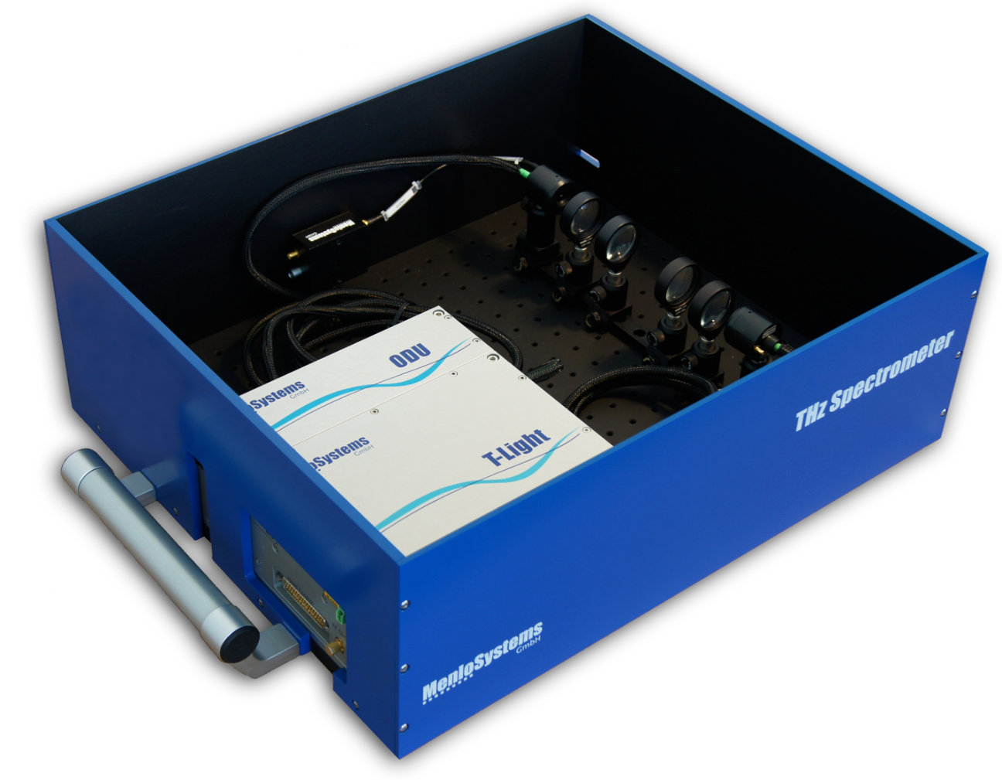
Image (350 dpi): MENLO_TERAK15_pic_pr.jpg
Caption: TERA K15 Mark II THz Spectrometer

Menlo Systems
Menlo Systems, a leading developer and global supplier of instrumentation for high-precision metrology, was founded 2001 as spin-off of the Max-Planck-Institute of Quantum Optics. Pioneers of the Nobel-Prize-winning Optical Frequency Comb technology, the Munich based company offers complete solutions based on ultrafast lasers, synchronization electronics and THz systems for applications in industry and research.

Contact Headquarters
Oliver Neutert
Head of Marketing
Menlo Systems GmbH
Am Klopferspitz 19a
D-82152 Martinsried
Germany
Phone +49-89-189166-152
Fax +49-89-189166-111
o.neutert@menlosystems.com

