Press Release
February, 2014
Optical fiber links for dissemination of ultra-stable optical clock signals
Optical atomic clocks based on optical so-called “clock” transitions in atoms or ions are extremely stable and accurate and outperform any other clock technique. Timing signals from such clocks are important to improve today’s most demanding experiments from basic research to metrology and telecommunication. Continued development means that these clocks must be compared to other similar clocks for reference.
Optical clocks are complex technical apparatus and are not transportable. Therefore, their signals have been disseminated between the clock labs or towards other users via radio frequency or satellite lines. However, for both approaches the stability and accuracy of the disseminated optical clock signal are strongly reduced.
Optical fiber links capable of disseminating signals without corrupting stability and accuracy provide an exciting solution to this problem.
At Photonics West 2014, Menlo Systems demonstrated optical fiber link technology: all you need is an Optical Frequency Comb from Menlo System (if you don’t have it already), a dark fiber or dark channel in a telecom fiber network connecting the optical clock with the outer world, Menlo Systems’ bidirectional optical amplifiers DUAL EDFA, and an interferometric fiber stabilization.That’s all.
Image: MENLO_Optical-Fiber-Links_pic01_pr.jpg (350 DPI)
Caption: Timing is everything. Connecting optical clocks with Menlo Systems
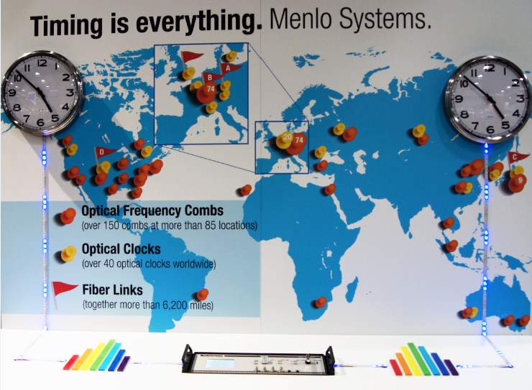
Image: MENLO_Optical-Fiber-Links_pic02_pr.jpg (350 DPI)
Caption: Connecting optical clocks with Menlo Systems’ frequency combs and the DUAL bidirectional amplifier DUAL shown at the Photonics West 2014

Menlo Systems
Menlo Systems, a leading developer and global supplier of instrumentation for high-precision metrology, was founded 2001 as spin-off of the Max-Planck-Institute of Quantum Optics. Pioneers of the Nobel-Prize-winning Optical Frequency Comb technology, the Munich based company offers complete solutions based on ultrafast lasers, synchronization electronics and THz systems for applications in industry and research.

Contact Headquarters
Oliver Neutert
Head of Marketing
Menlo Systems GmbH
Am Klopferspitz 19a
D-82152 Martinsried
Germany
Phone +49-89-189166-152
Fax +49-89-189166-111
o.neutert@menlosystems.com

